Rotational Torque
Torque: A measurement of the tendency of a force to produce a rotation about an axis.
Torque = perpendicular force x lever arm or τ = F x d
The lever arm, d, is the distance from the pivot point, or fulcrum, to the point where the component of the force perpendicular to the lever arm is being exerted. The longer the lever arm, the larger the torque. This is why it is easier to loosen a tight screw with a long wrench than with your hand or a short pair of tweezers.
If a torque causes a counterclockwise rotation of an object around the fulcrum, it is positive, If the torque causes a clockwise rotation of an object around the fulcrum, it is negative. This convention works even if the object remains balanced and the torques just attempt to cause a rotation.
The SI unit for torque is the newton-meter (Nm). However, unlike work, which is measured in the same unit, torque is not a form of energy and is not equivalent to a joule.
In cases of equilibrium, all the torques are balanced. For example, if two people are sitting on either side of a seesaw and they want to remain level, they can position themselves so that all the torques on one side of the seesaw equal all the torques on the other side. The total torque on a system equals the sum of all the individual torques, or
τ = (F1 x d1) + (F2 x d2) + …
The … means that there may be more than only two torques acting on a system at any one time. Keep in mind that when an object is balanced, all the torques must also balance.
Therefore, the total torque, τ , is zero.
Center of Gravity: The point on any object that acts like the place at which all the weight is concentrated.
The weight of an object, which acts as if it is concentrated at the center of gravity, is one of the forces that can causes it to rotate. The weight produces a torque if the object is not supported at its center of gravity.
- Ned tightens a bolt in his car engine by exerting 12 N of force on his wrench at a distance of 0.40 m from the fulcrum. How much torque must Ned produce to turn the bolt?
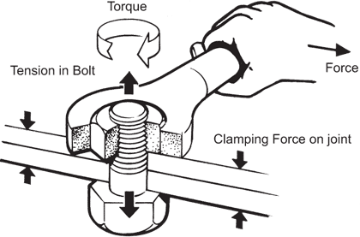

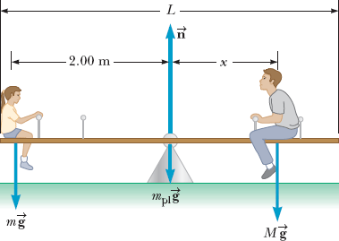
- Mabel and Jim are seesawing on the school playground and decide to see if they can move to the correct location to make the seesaw balance. Mabel weighs 40.0 kg and she sits 2.00 m from the fulcrum of the seesaw. Where should 45.0 kg Jim sit to balance the seesaw?
- A water faucet is turned on when a force of 2.0 N is exerted on the handle, at a distance of 0.060 m from the pivot point. How much torque must be produced to turn the handle?
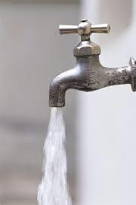
- Ann and Sally, two paramedics, rush a 60.0-kg women from the scene of an accident to a waiting ambulance, carrying her on a uniform 3.00-kg stretcher held by the ends. The stretcher is 2.60 m long and the women’s center of mass is 1.00 m from Ann. How much force must Ann and Sally each exert to keep the woman horizontal?
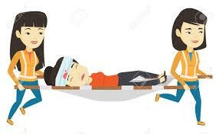
- Tracey is building a mobile to hang over her baby’s crib. She hangs a 0.020-kg toy sailboat 0.010 m from the left end and a 0.015-kg toy truck 0.20 m from the right end of the bar 0.50 m long. If the lever itself has negligible mass, where must the support-string be placed so that the arm balances?

- When pedaling a bicycle, when do you apply the maximum and minimum torques? (Assume the downward force of your foot is constant.)
What is the value of the minimum torque?
- Where would you say the centers of mass of the following systems would be?
- The Earth and moon:
- The Sun and the Earth:
- The Solar system:
- From the image below, why does a lower center of gravity give an object greater stable equilibrium?
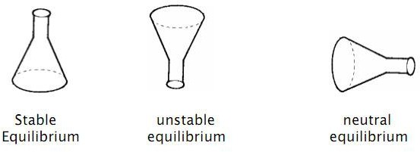

- When an object, such as a ball or cylinder, rolls down an incline from rest, what produces the rotational motion? (Hint: Discuss torque, CofG, and support base)

- Which truck is going to topple? Explain.
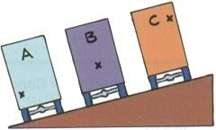
- Which situation is more stable? Explain.
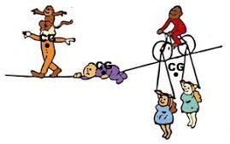

- How does standing with your legs apart, for example, on a moving bus, increase your stability?
Is the stability increased in all directions?
- Why doesn’t this dancer topple?
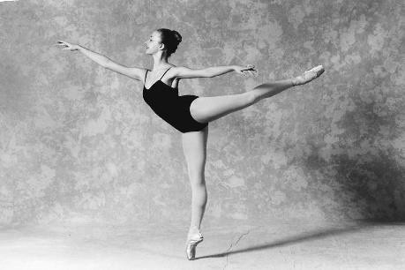
- Does putting “big wheels” on a pick-up truck make it more stable? Explain. (Hint: What is the purpose of the bar behind the cab in the image?)
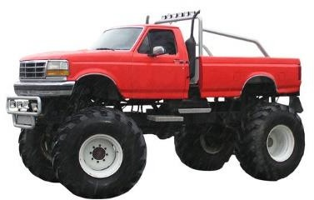

- Who is the most unstable in the image? (Note: “+” marks the CofG) Explain.
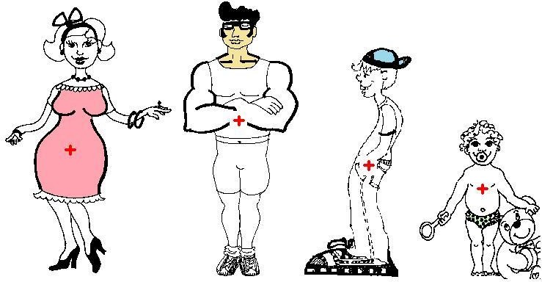
- To prevent toppling, what does a pregnant women and a back-packer need to do? If not, how does this effect the back spine?
